**PRACTICAL NO:4**

**PART B**

**Code:**

**1)Strings.html**

<html>

<body>

<p>Click the button .</p>

<button onclick="myFunction()" value="" >vovel</button>

<button onclick="myFunction2()" value="">reverse</button>

<button onclick="myFunction3()" value="">concat</button>

<p id="p1"></p>

<br>

<p id="p2"></p>

<br>

<p id="p3"></p>

<br>

<script>

function myFunction() {

var s = prompt("Please enter String");

var i=0;

var n;

if (s != null) {

//alert(s);

n=s.length;

//alert(n);

for(i=0;i<n;i++)

{

if(s.charAt(i)=="a" || s.charAt(i)=="e" || s.charAt(i)=="i" || s.charAt(i)=="o" || s.charAt(i)=="u" || s.charAt(i)=="A" || s.charAt(i)=="E" || s.charAt(i)=="I" || s.charAt(i)=="O" || s.charAt(i)=="U")

{

alert("character : "+ s.charAt(i) +" position : "+i);

document.getElementById("p1").innerHTML+=" <br>character : "+ s.charAt(i) +" position : "+i;

}

}

}

}

function myFunction2() {

var s = prompt("Please enter String");

var i=0;

var n;

if (s != null) {

var str=s;

//alert(s);

var splitString = str.split("");

var reverseArray = splitString.reverse();

str=reverseArray.join("");

//alert(reverseArray);

alert(str);

document.getElementById("p1").innerHTML=" reverse: "+str;

}

}

function myFunction3() {

var s = prompt("Please enter String");

var i=0;

var n;

if (s != null) {

var s2=prompt("Please enter second String");

var str=s.concat(s2);

alert(str);

document.getElementById("p1").innerHTML=" concatination: "+str;

}

}

</script>

</body>

</html>

**2)sort.html**

<html>

<body>

<h1>SORT</h1><br>

<!-- input:<input id="p1" type="text" name="t1" \>

output:<input id="p11" type="text" name="t1" \> -->

<button onclick="sort()">INSERTION SORT </button>

<button onclick="sort2()">BUBBLE SORT</button>

<button onclick="sort3()">SELECTION SORT</button>

<p id="p1"></p>

<p id="p2"></p>

<script>

function sort()

{

// document.getElementById("p1").value ="";

// document.getElementById("p11").value ="";

var a=[1,2,3,56,45,23,12];

var i=0;

a=insertion_Sort(a);

document.getElementById("p2").innerHTML="sorted array "+a;

}

function insertion_Sort(arr)

{

for (var i = 1; i < arr.length; i++)

{

if (arr[i] < arr[0])

{

arr.unshift(arr.splice(i,1)[0]);

}

else if (arr[i] > arr[i-1])

{

continue;

}

else {

for (var j = 1; j < i; j++) {

if (arr[i] > arr[j-1] && arr[i] < arr[j])

{

//move element

arr.splice(j,0,arr.splice(i,1)[0]);

}

}

}

}

return arr;

}

function sort2()

{

// document.getElementById("p1").value="";

// document.getElementById("p11").value="";

var b=[12,21,23,34,45,43,2];

var i=0;

document.getElementById("p1").innerHTML="Unsorted array "+b;

b=bubble_Sort(b);

document.getElementById("p2").innerHTML="sorted array "+b;

}

function swap1(arr, first_Index, second_Index){

var temp = arr[first_Index];

arr[first_Index] = arr[second_Index];

arr[second_Index] = temp;

}

function bubble_Sort(arr){

var len = arr.length,

i, j, stop;

for (i=0; i < len; i++){

for (j=0, stop=len-i; j < stop; j++){

if (arr[j] > arr[j+1]){

swap1(arr, j, j+1);

}

}

}

return arr;

}

function sort3()

{

// document.getElementById("p1").value ="";

// document.getElementById("p11").value ="";

var c=[12,21,23,34];

var i=0;

document.getElementById("p1").innerHTML="Unsorted array "+c;

c=selectionSort(c);

// for (i = 0; i<c.length; i++)

// {

// //alert(a[i]);

document.getElementById("p2").innerHTML="sorted array "+c;

// }

}

function swap2(items, firstIndex, secondIndex)

{

var temp = items[firstIndex];

items[firstIndex] = items[secondIndex];

items[secondIndex] = temp;

}

function selectionSort(items)

{

var len = items.length,

min;

for (i=0; i < len; i++){

min = i;

for (j=i+1; j < len; j++){

if (items[j] < items[min]){

min = j;

}

}

if (i != min){

swap2(items, i, min);

}

}

return items;

}

</script>

</body>

</html>

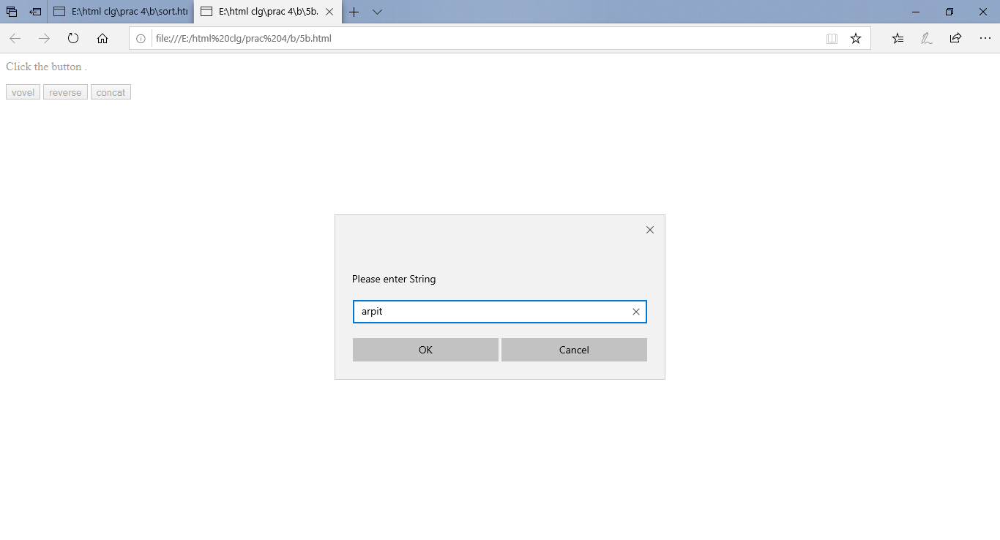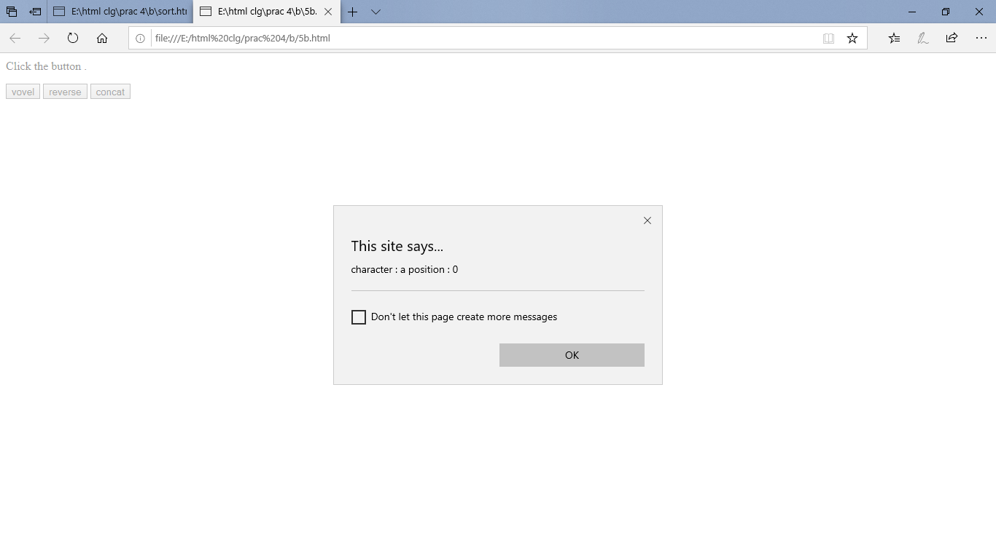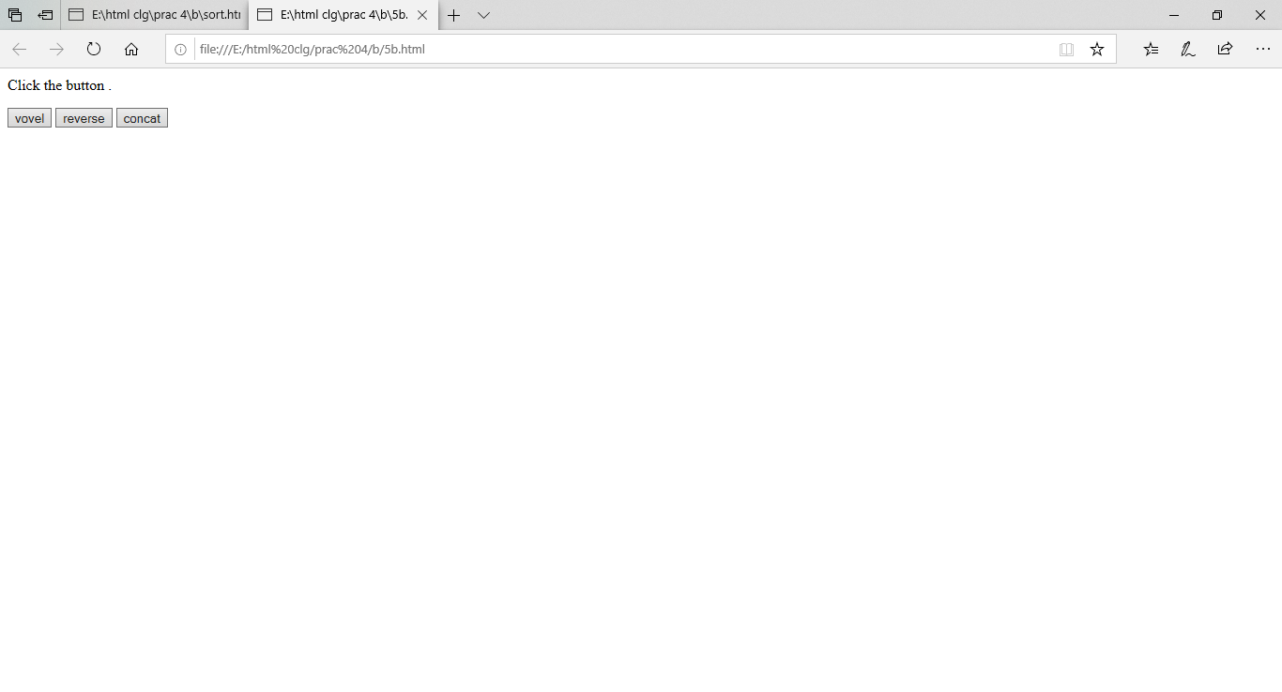**OUTPUT:**

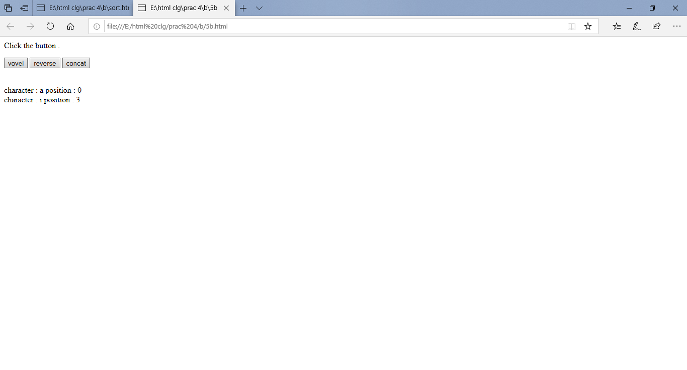

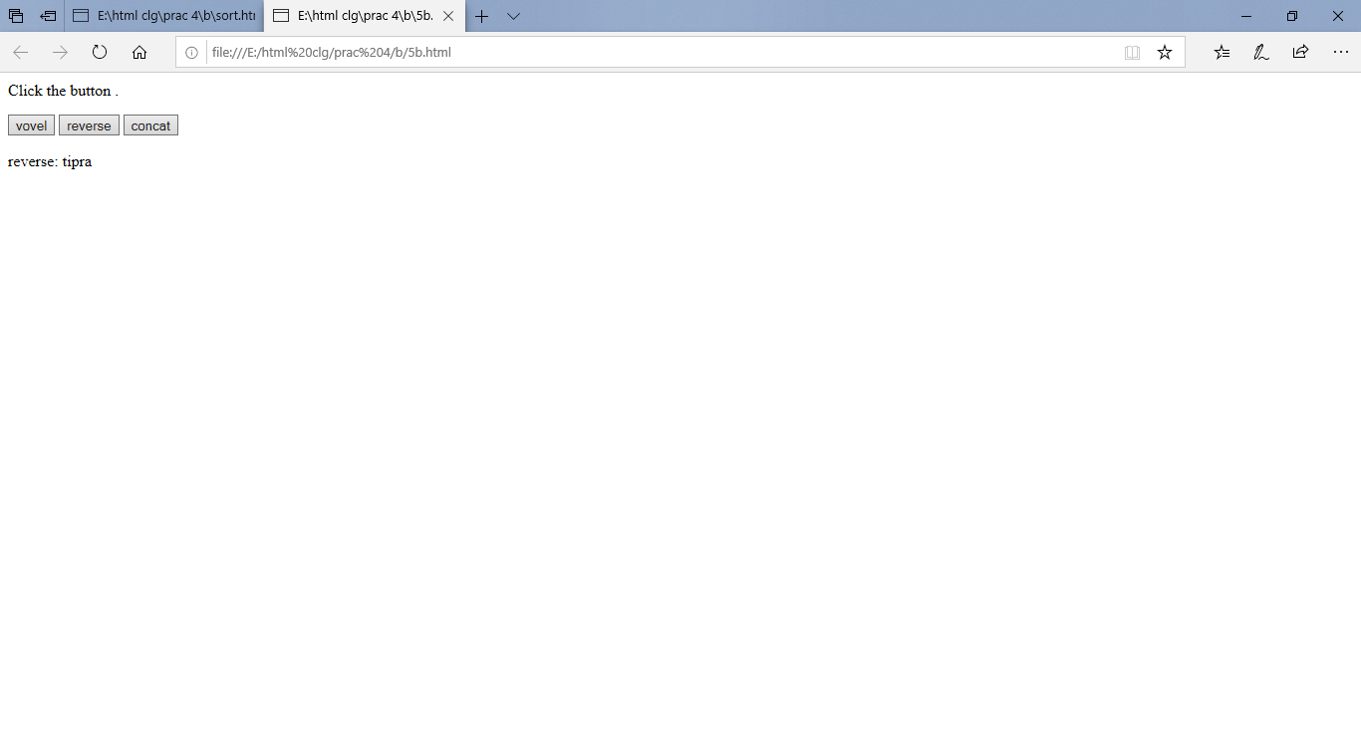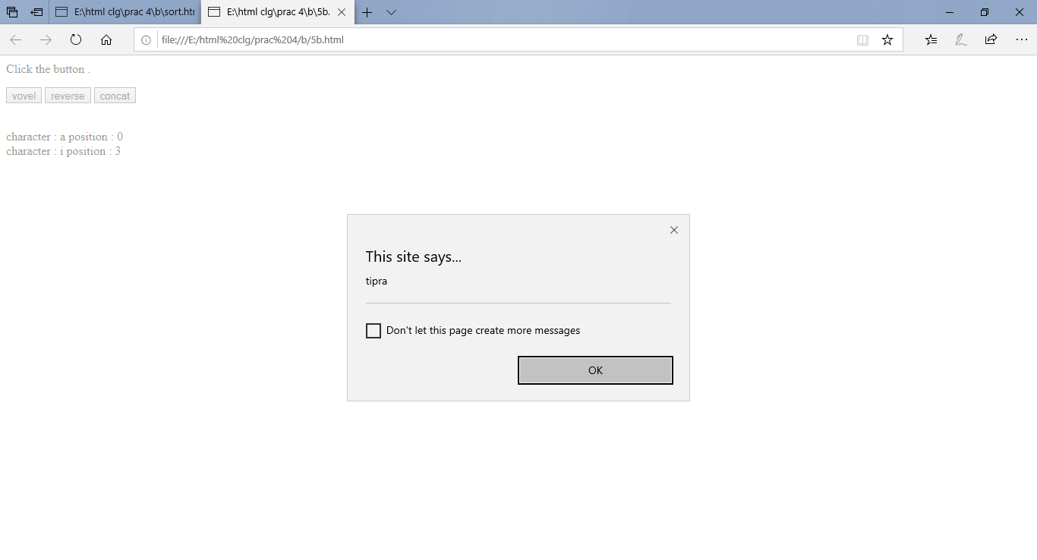

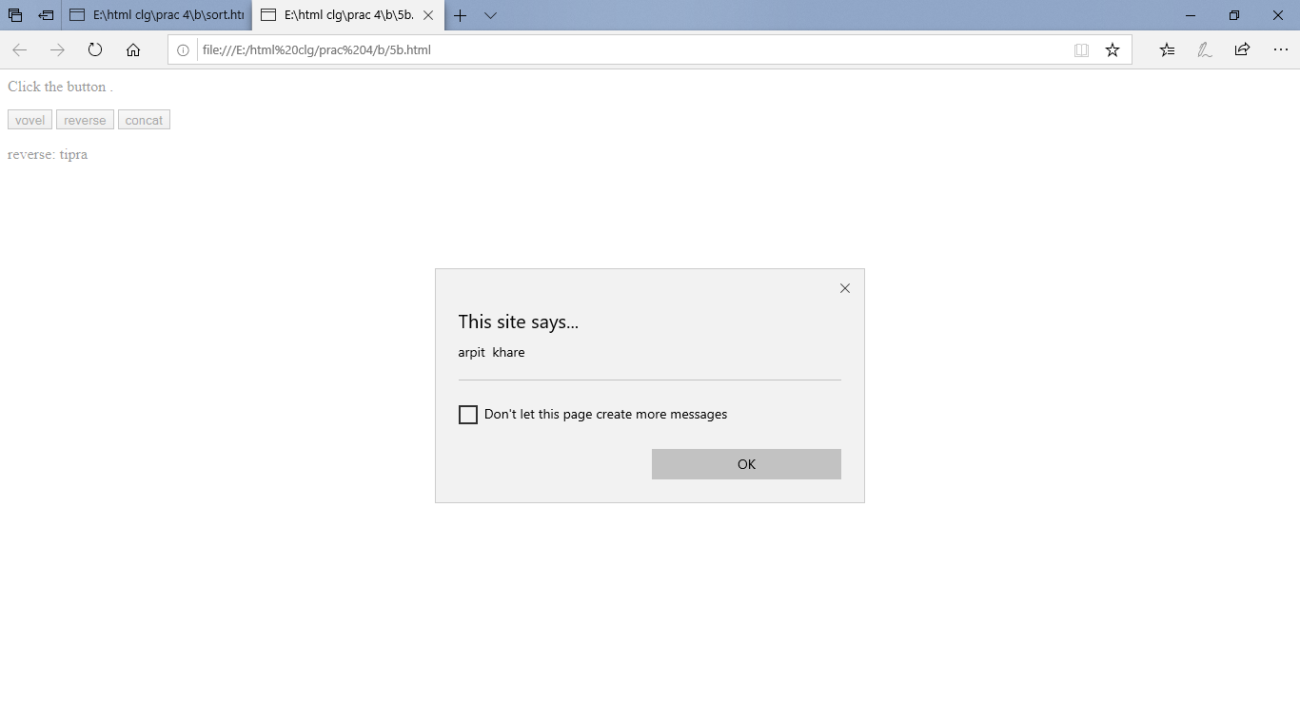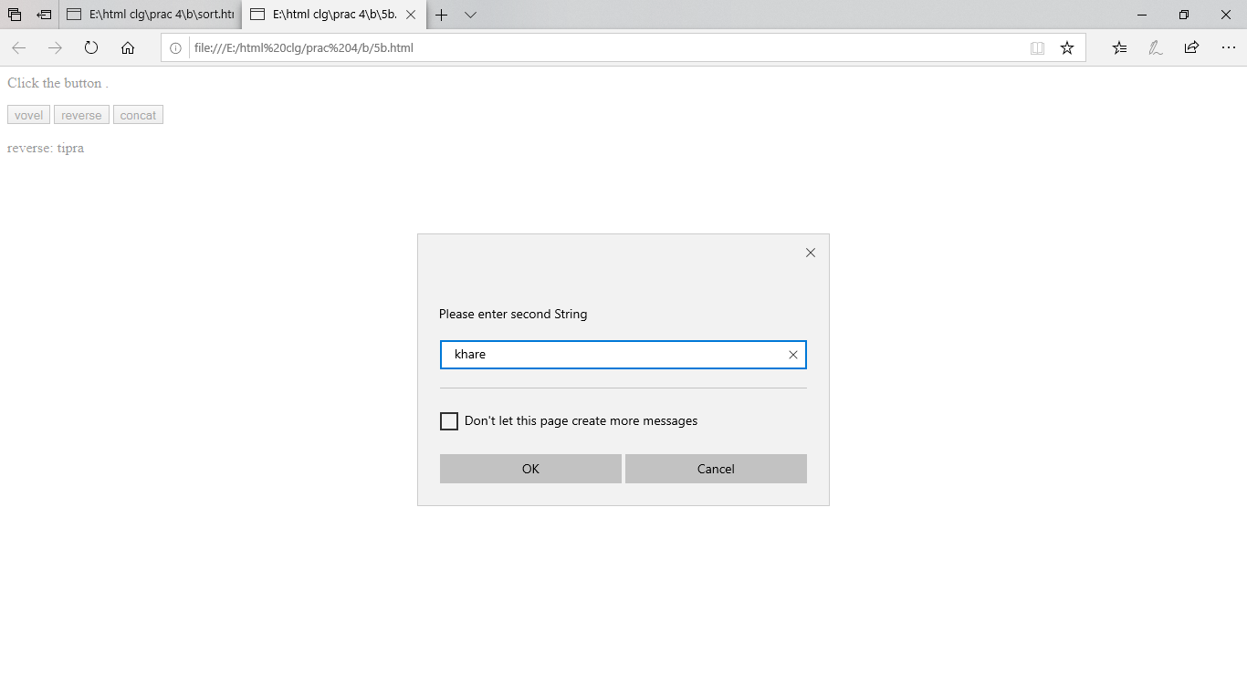

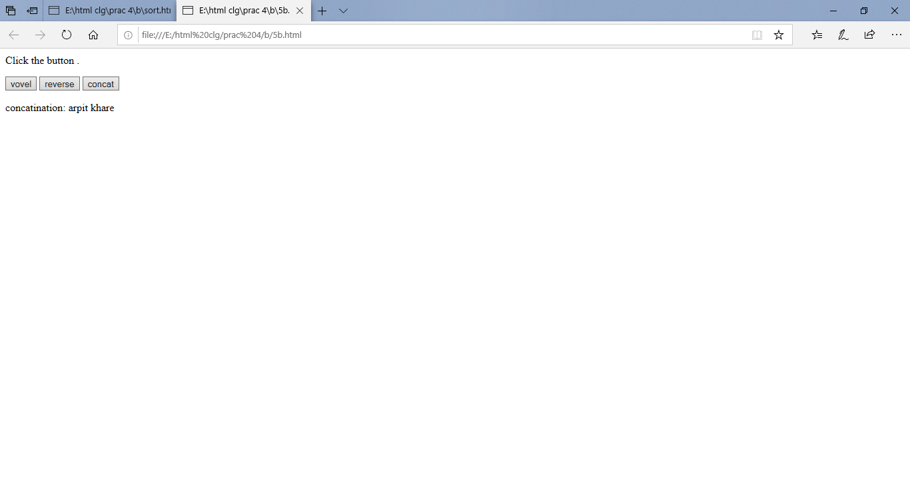

**SORTING**

